HELP US EARN FREE MONEY FOR OUR SCHOOL
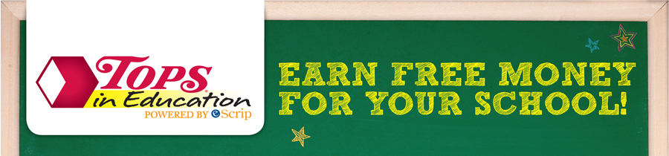
TOPS in Education > Participating Products >

TOPS in Education
At TOPS Friendly Markets, we are committed to helping the communities we serve. Schools are a big part of those communities.
That's why we are excited to bring you TOPS in Education, a program that makes it easier to get additional money for school improvements and programs.

Here's how it works:
- Register your TOPS BonusPlus®.
- Select your school(s) of choice (grades K-12) from the list of schools that have registered (you may select up to three schools).
- Purchase participating TOPS brand, Full CircleTM, TopCare®, Tippy Toes, Valu Time® and Best Yet® products with your TOPS BonusPlus® throughout the 2016-2017 TOPS in Education program year.
- TOPS contributes up to 5% of your purchase to the school(s) you have chosen. The more you shop, the higher percentage we donate!

Participating Products
When you purchase TOPS brand, Full CircleTM, TopCare®, Tippy ToesTM, Valu Time® or Best Yet products* with your TOPS BonusPlus®, TOPS contributes up to 5% of the purchase to the school of your choice (grades K-12).
***Please note, you need to re-register your card each school year***
Please complete the form below and return to school by September 30, 2016. You will be entered to win a $25.00 Tops gift card.

My Tops Bonus Card is registered and Southtowns Catholic School has been designated as my school.
Name: ______________________________________________________________
Phone Number: _______________________________________________________

