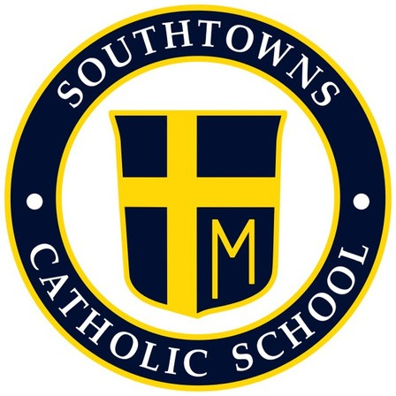
Southtowns Catholic School
Home School Association
13 Jan 22 Meeting Minutes

- Call to Order (Russ Clark)

- Opening Prayer (Casey Hatton)

- Review and approval of the Minutes (Russell Clark) 6pm Southtowns Catholic Gym

- Principal Update (Marc Bandelian)
. The number of breakfasts served for December was 544 (36 per day) and lunches 1,523 (108 a day).
. Students who bring lunches are still able to choose 3-5 items from the lunch line if they would like.
. There is a possibility we will be receiving free lunches next school year as well.

. Covid Update- If a student was in close contact and is symptom free, they are to have a 5-day quarantine now.
. The Covid tests kits that were sent home were given to the school free of charge for families to use as they please, or if anyone is symptomatic and would like to take the tests. However, these tests are not acceptable to come back to school if a student tests positive. Students must receive an official Covid test in order to be able to come back to school.
. Daily reports are sent out to the Erie County Dept. of Health with positive Covid numbers.

. This year’s Christmas concert has been cancelled. There are ideas to have possible smaller programs/concerts for the students/families, possibly for the smaller holidays that are coming up.

. Catholic Schools Week starts January 30th and will kick off with 9:30 mass where students will be participating in the mass readings and ushering. Following mass from 10:30-1pm will be the schools open house.
. The Catholic school committee is setting up the schedule for Catholic school’s week regarding what the dress down will be for each day and the theme/activities for the week.

- Treasurer Report (Megan Almond / Venessa Erickson)
. Total money earned so far is $17,538.48
.Script cards $3,694.10
.Tops Education $629.06
.SEFA $140.55
.Santa’s Secret Shop total is not yet in

- Review of recent events (Russ Clark)

  - Operation Christmas Cheer 6-17 Dec

    - Sustain- Yes was successful, students and family members loved. 3+families received.

    - Improve- Possibly have the Cutoff date for money/donations earlier so that shopping can be done sooner. Instead of the 17/19th try for a week earlier.

  - Santa’s Secret Shop 13 – 15 Dec (Lauren, Elena)

    - Sustain- Yes, students and families enjoyed this special event. Quality items and donations.

    - Improve- No food (too messy and hard since students should not be bringing the food back to classrooms).
. Work on scheduling so that each grade has enough gifts to choose from
. Better stock on items that are sold in high frequency.
. Possibly have a craft night where gifts can be made so money can be saved.
. Possible Vendors (Arts and Craft show) so we can have a Saturday shopping day.

  - Staff Christmas appreciation 22 Dec

    - Sustain- Yes Staff appreciated the breakfast, food was good!

    - Improve- Try to move to a different day and a full day so that it does not land on Father Sean’s appreciation lunch. Maybe do a brunch instead?
. Agree on how to pay for Script cards ahead of time so there is no confusion for room parents/HSA

- Reports of Special Committees

  - Meat Raffle March 12^{th (}Russ and Brien)
.480 people, 60 tables
.6 sets of tickets, 11 times wheel and 6 pieces of meat at a time distributed.
. The meat is ordered ahead of the event, so the number of people/tables was needed.
. A&C Meats
. Volunteers Needed

  - Easter Candy Sale January 25th (Megan Almond)
. Fowler’s Chocolate
. Working of finalizing the contract, should be all set in a few days
. January 25th-March 4th
. Trying to aim for $5,000 so that we can receive a 40% profit for the school
. Chocolate will be delivered March 25th to the school, families will pick up around April 1st so there will be the entire week where students are in school before break.
Fowler’s puts the orders together, each family has a code and delivery is free if families pick up right from the school. Other orders being shipped elsewhere will be charged the shipping fee.
. On the Fowler’s website where the ordering is done, people will be able to make a donation to Southtowns Catholic that will go toward the $5,000 goal, and there are also magazine orders that also goes toward the goal amount if interested.

  - Father / Daughter Dance Feb 5th (Danielle Ahrens / Venessa Erickson)
. Lights camera action/ red carpet theme.
. Have prospective equipment for music (not a dj).
. Need to figure out budget still- will be advertising soon so we can get numbers.
. Cost will be $25 per family.

  - Valentines for Vets Feb 11 (Colleen Curren)
. Valentines will be made during Catholic Schools week for service members.
. USO will be receiving donations/cards.
. Working on the flyer/website details.
. Last year the school did a dress down/donation day to raise money for this.

- New Business

  - Kids Night Out, 10 Feb
. Bypassed for now

  - Double Good Popcorn Fundraiser, 7 Mar
. Bypassed for now

  - Fan Cloth, 1 Mar
. Catalogs will be coming soon (hopefully Monday 17th) to be kicked off next week.
. Families will be able to order Southtowns Catholic gear for kids and adults virtually and have them sent right to their homes.
. Students can order items but they will only be allowed to wear on dress down days and for special events such as school spirit days etc.
. Profit $4 margin, receive 60 sales and the profit margin jumps up.

- Open Floor
. Summer Fest for students with food, vendors, etc. Will discuss further.
. Super Bowl squares? Checking the legality and guidelines first in order to set up.

- Adjournment (Russ Clark) 7pm

