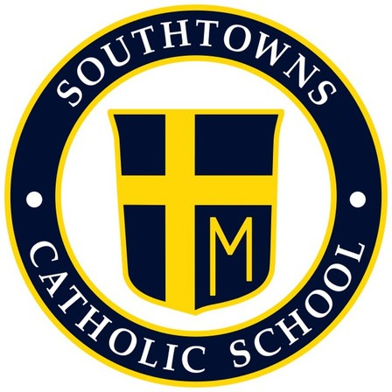
Southtowns Catholic School
Home School Association

Initial HSA Board Meeting
September 27th, 2021- 6:00pm
St. John Paul II Conference Room

In Attendance: Russ Clark, Annemarie Tubinis, Megan Almond, Vanessa Erickson, Margaret West, Casey Hatton, Susan Langley, Barb Manely, Brian Pacillo and Natalie Zorn

Recording Secretary: Casey Hatton

October Events
Spooky Shenanigans Sweepstakes
- Consensus to change name of the raffle to “Spooky Shenanigans Online Raffle”
- Board agreed on prizes
- Board agreed on ticket prices
  - Give option for 3 for $25
= Natalie will update flyer and send out to Board to approve. Raffle will go live October 1st with drawing October 31st.

Fall Bulb Sale
- Dolly (parishioner) is donating 1200 bulbs to the school
- Distribute evenly into paper bags and sell for $5 or $6.
  - 6 to a bag with 2 of each
    - Tulips, daffodils and hyacinthus
- Pre-sale. Order forms return by the 15th
  - Note: first come, first serve
- Will sell at Trunk or Treat and the following day

Trunk or Treat- October 22nd
- Vanessa Erickson volunteered to chair
  - Can put her phone number on flyer
- To Do:
  - Accessible bathrooms- Barb Manley will look into
  - Sound system for music- Margaret West asking people
  - Advertising- Natalie
  - Food trucks- Natalie
  - Parking/ traffic- Vanessa volunteered husband
  - LVFD- Vanessa
- Last year the school provided gloves and masks

Mother/Son Mass and Dinner
- Sherry Miller has chaired Committee previous years and has volunteered to do it again.

November Events
Thanksgiving Food Drive
- Beginning November 1st, we’ll start collecting food from each grade (each grade is asked to bring in different kinds of food).
- Work with administration to get distribution list of deserving families
- Distribute the food November 23rd 4pm- HSA Board will meet to sort, pack up and distribute food.

Wreath Sale- POSTPONED UNTIL NEXT YEAR
- Pre-purchase 50 of the 20” ring wreaths, add ribbon and sell after mass. Mark up price a little for a profit
- Annemarie will call to see if we can get a discount for buying in bulk.

Meeting concluded at 8:15pm

