Hershey Ice Cream 2022-2023, Go on hersheysicecream.com under smart snacks and let me know your child’s favorite dessert and I will order some of that flavor.
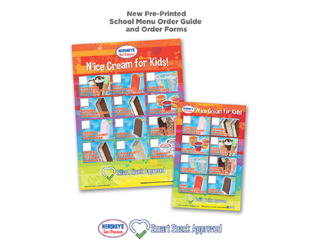
$.75 ice cream cups and everything else $1.00 (cones, sandwiches, juice bars etc).

